GitHub Business Cloud Implementation
Table of Contents

1. Document Control 2
1.1. Change Record 2
1.2. Reviewers/Approvers 2
2. INTRODUCTION 3
2.1. Description 3
2.2. High-Level Activities Sequence 3
3. Super user setup 3
4. repositories Setup and Access management 6
4.1. Repositories creation: 6
4.2. Repository Structure and workflow 7
4.3. Permission level for an organization: 8
4.4. Creating Team and adding members to the Team: 8
4.5. Team Structure: 10
4.6. Managing Team’s access to an organization repository: 11
5. Branching strategy 12
6. Github authentication with SAML single sign-on 15
6.1. Process Overview: 15
6.2. Integrate SAML SSO with GitHub: 15
7. Installation of Git in the Users’ local machine and for ide integration 16
7.1. Process Overview: 16
7.2. Steps for Git installation 16
7.3. User Identity Setup 17
7.4. User’s Editor 17
7.5. Checking User Settings 18
7.6. Getting Help 18
7.7. IDE Integration 18

Document Control
The purpose of document control is to track all changes and updates made to management procedures and serves to function as version control.

Change Record

Date | Author | Version | Change Reference
01/16/2019 | Jitendra Ku. Pradhan | 0.1 | Draft Document
09/13/2019 | Lokesh Makkineni | 0.2 | Updated repository management,workflow,branching strategy, Team structure,SSO

Reviewers/Approvers

Date | Name | Comments
01/17/2019 | Rohitashva Pandey | - First draft review of version 0.1
09/25/2019 | Rohitashva Pandey

INTRODUCTION

Description
This document is an overview document on setting up the GitHub Business Cloud solution for the Development community at Chemours. This document also details the steps to enable the users to manage their code base through appropriate repositories. This document also entails the various solution configuration aspects such as managing the authentication, permission and access control and the steps to integrate of the GitHub business cloud with the ADFS solutions for SAML Single sign-on authentication.

High-Level Activities Sequence

Stage 1

GitHub Business Cloud Super user setup

Stage 2

Access and permission Management

Stage 3
Single Sign-on Setup

Stage 4
User and Teams’ Onboarding

Super user setup
  - Step: 1
- Signup for a New GitHub Enterprise Cloud Account by giving the Username, email address, password of the super user.

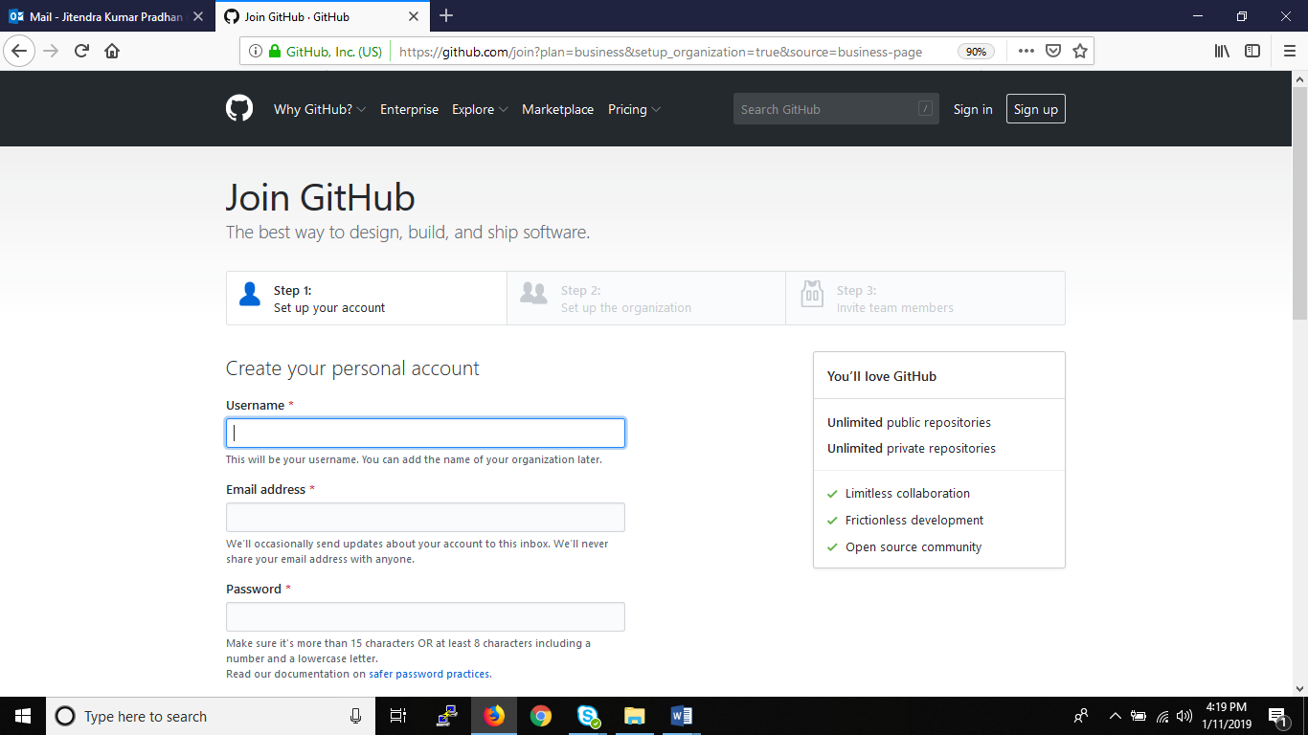

  - Step: 2
- Create an organization by providing the below information:
  - Organization name
  - Billing email address
  - Choose the Enterprise Cloud plan ($21).
  - Choose the Payment method by giving the credit card details.
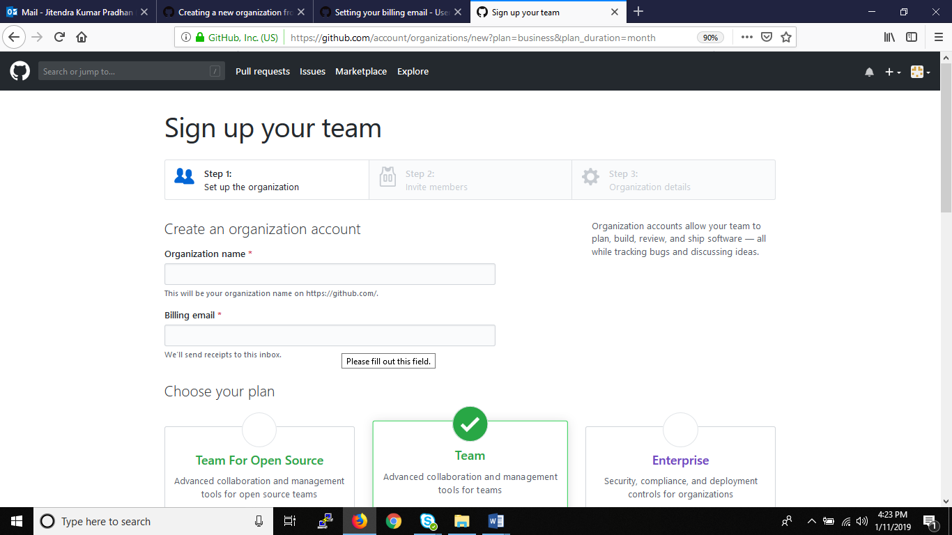
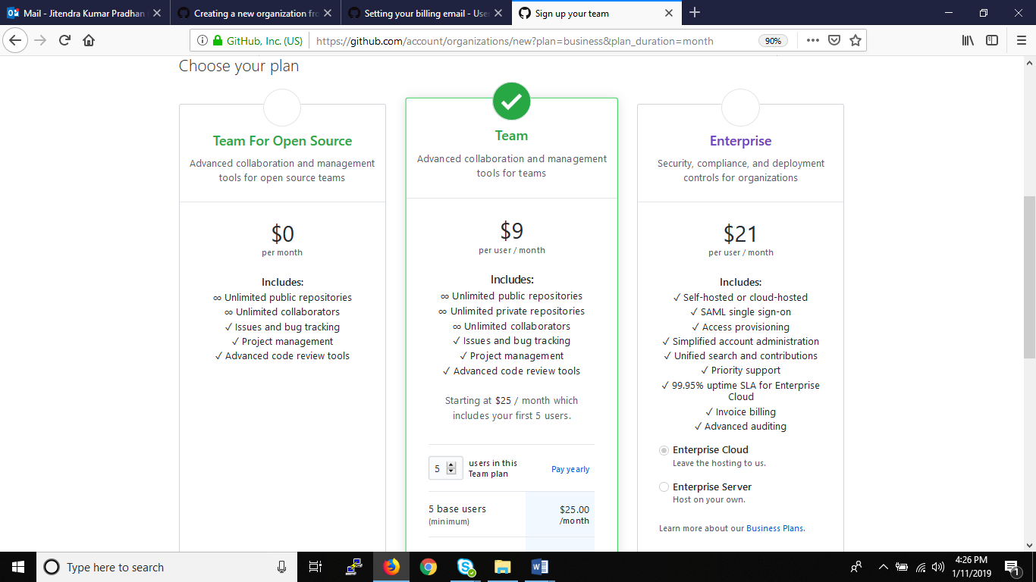



  - Step: 3

- Organization is created with the name “ Chemours”:
URL: https://github.com/thechemoursco
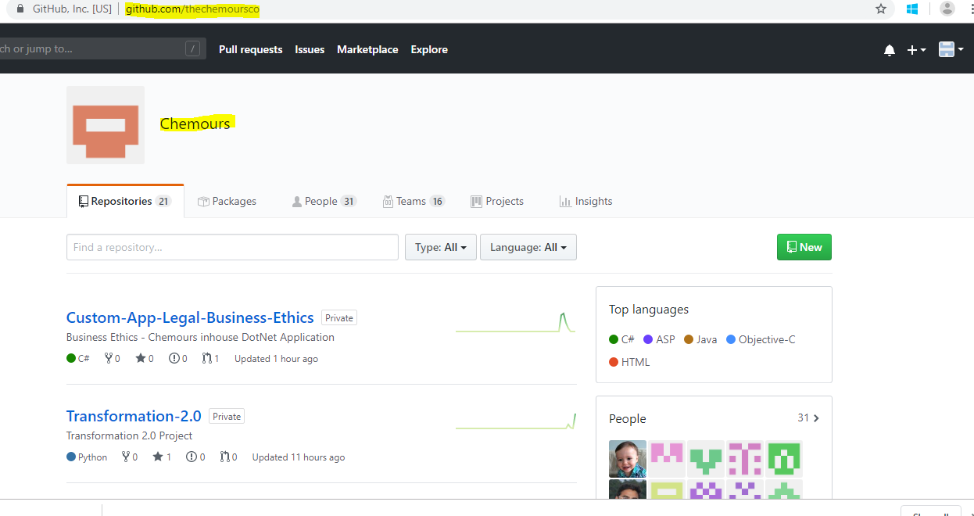

repositories Setup and Access management

Repositories creation:
- Repositories are created for each application with the below naming convention
<Application Name>-<module>-<component>

Microsoft Applications
Custom-App-Legal-Business-Ethics
Custom-App-Teflon-Assurance
Custom-App-eCAPEX
Custom-App-CEAA
Custom-App-Teflon-Hangtag
Custom-App-FEED
Custom-App-ePPP

- To create a repository,
Access GitHub, Repositories New.
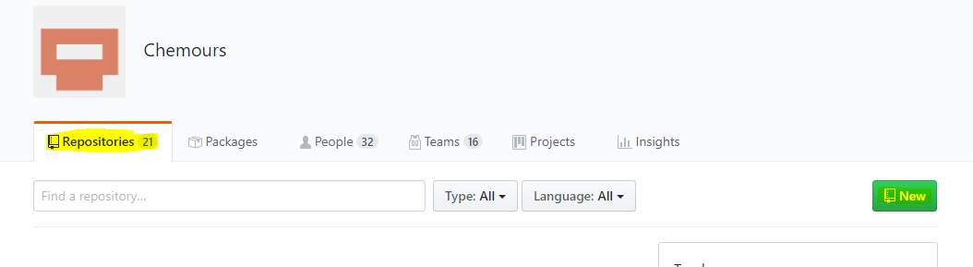
Provide the details and click on Repository
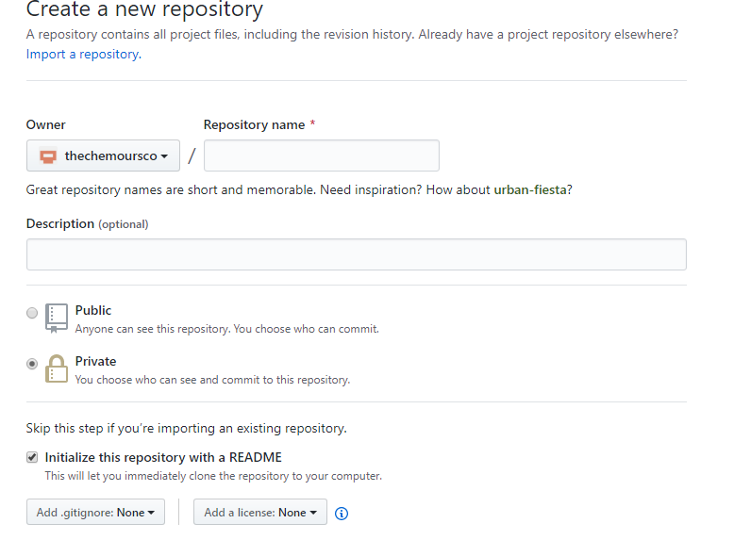

Repository Structure and workflow
- Uploaded source code on the repository
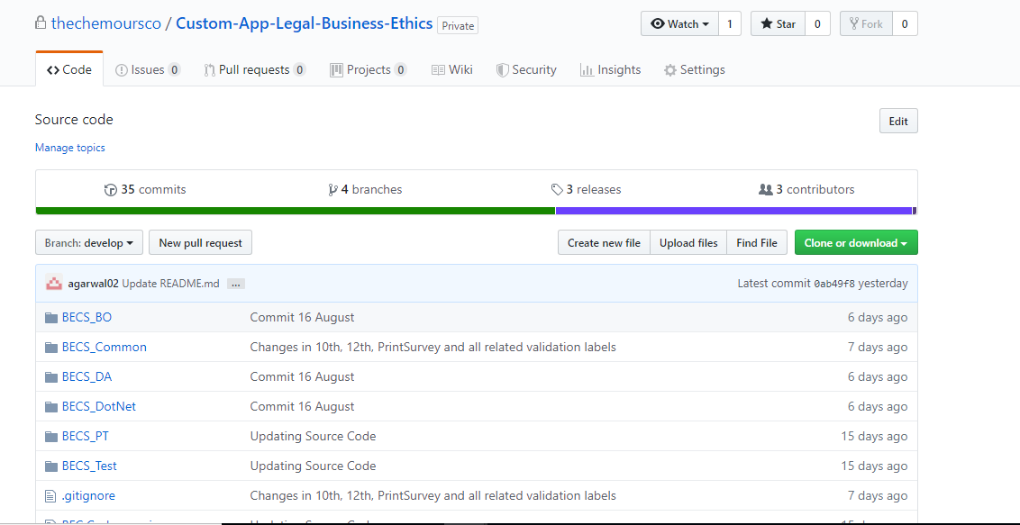

- Added .gitignore file on the repository based on the code base uploaded to the repository.
    - Dot Net –>Visual studio
    - IOS –>Swift
    - Android ->Android (java)
- Use of the gitignore file is to restrict the unwanted files (formats .class, .dll etc. or names) to upload on the repository.
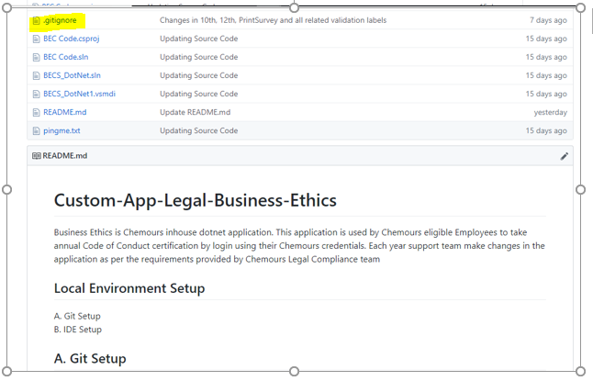
- Updated README file for each repository to quick understanding of the working with GITHUB Repository.

Permission level for an organization:
- Owners defined in GitHub shall have complete administrative access. This role should be limited to only a few people in Chemours.
- The Organization owner and the admins can manage the repository access and permissions for the users.
- Members have the default role for everyone else.

Creating Team and adding members to the Team:
- Access GitHub organizational portal

Access GitHub, TeamsNew team
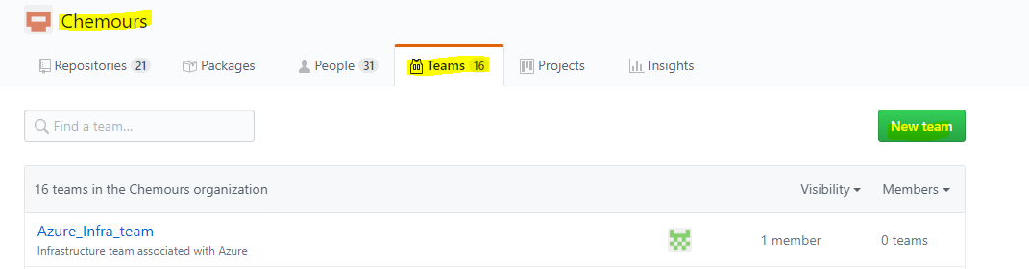
- Fill the details of the opened tab and click on create. Select parent team while creating child teams.
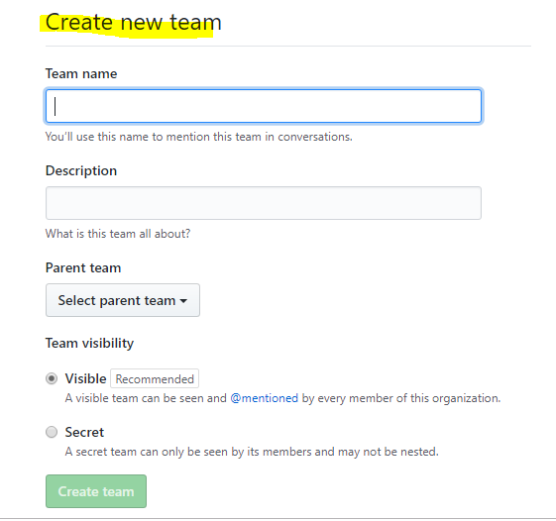
- Adding members to the team
Click on the team where we have to add member and click on the + button and invite the user to the team.

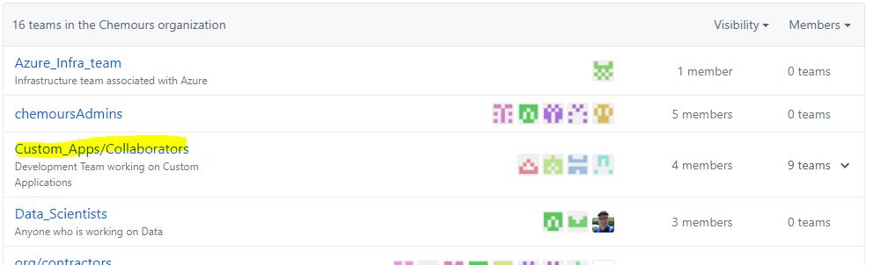
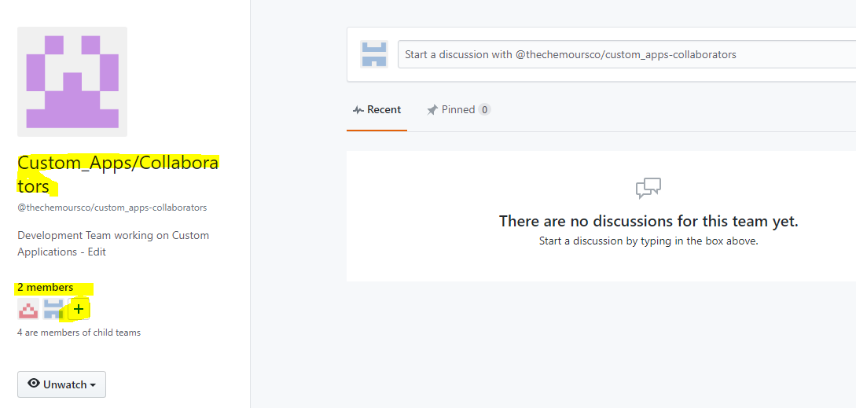

Team Structure:
- Created Parent team and added child teams.
- Parent team is created as “custom_Apps/collaborators”.
- Child teams are created based on code base as below

Example:
DotNet_Custom_Apps/collaborators
DotNet_Custom_Apps/Approvers
Android_Custom_Apps/collaborators
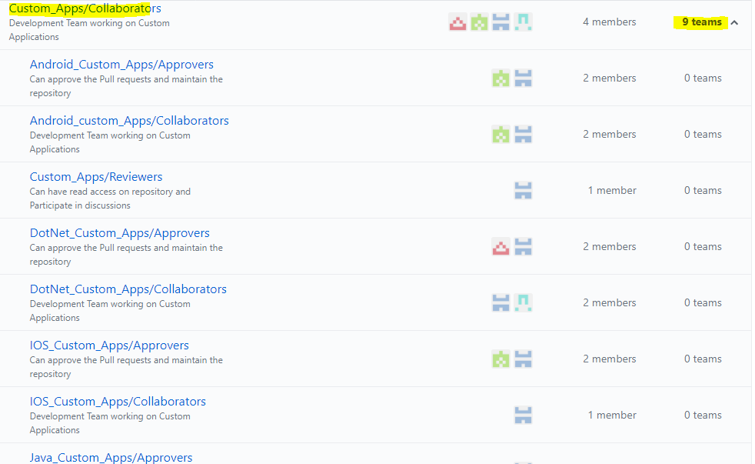

Managing Team’s access to an organization repository:
- Organization owners and team maintainers can add repositories to a team, as well as change the team's read, write, and admin access to the repository.
- If you add or remove repository access for a parent team, each of that parent's child teams will also receive or lose access to the repository.
- Collaborators have the write access over the repository.
- Approvers have the admin access over the repository.
- Reviewers have Read-only access over the repository.
- Adding team to the repository

Repository Settings collaborators and Teams add the team with selected access
- Teams are added to the repository.

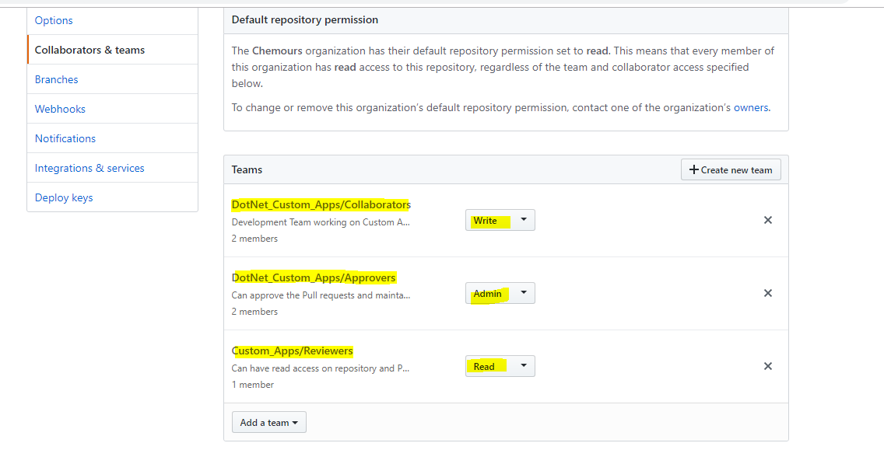

Branching strategy
- The central repo holds two main branches with an infinite lifetime: Master, develop.
- The master branch at origin should be familiar to every Git user. Parallel to the master branch, another branch exists called develop.
- Origin/master branch is the main branch where the source code of HEAD always reflects a production-ready state.
- The Origin/develop will be the main branch where the source code of HEAD always reflects a state with the latest delivered development changes for the next release. Some would call this the “integration branch”. This is where any automatic nightly builds are built from.
- You will never commit to master and develop branches directly.
- Developers Creating new branch from the develop branch with versioning and make a pull request to merge the changes with develop branch.
- Can create a parallel branch with develop in the following pattern.
Example:
develop_1.0/feature/2019_Enhancements
develop_2.0/feature/<feature title>
develop_1.1/bugfix/<bugfix title>

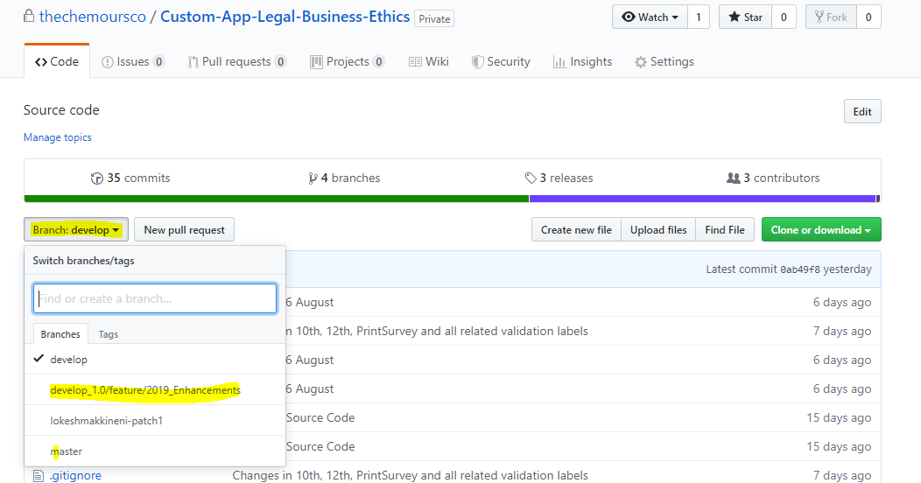
- Updated default branch as “develop”
- Branch Protection rules enabled for develop and master branch. To prevent or control accidental commits on the branch.
- Open the pull request to merge the changes updated on new branch with develop branch. Assign approvals, to approve the pull request and merge the changes.

Access Repository, Pull Requestnew pull request

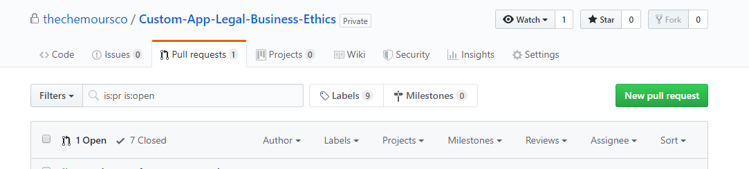

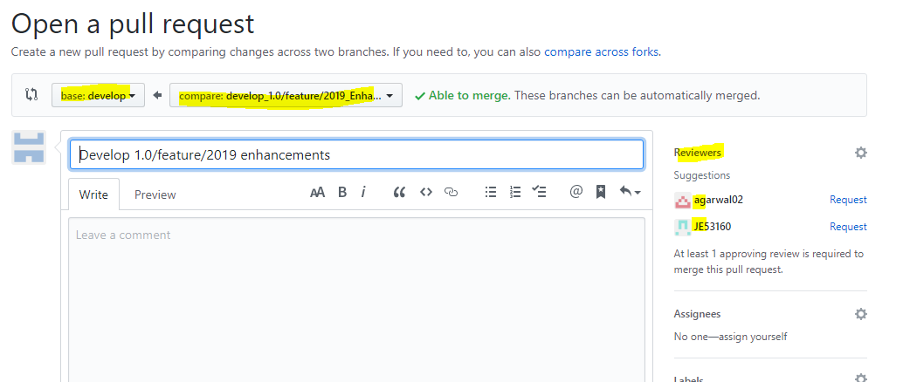

Base (target): Branch on which changes to be merged

Compare (source): Branch which need to be merged with

- Once Pull request is raised, approvers get notified and they can approve the pull request and merge the changes with develop branch.
- Only pull request for mater branch should be from develop branch and that should be raised when code is ready to deploy on production.
- Release: While all source code changes are merged with develop branch and ready to release. Can create a release from the develop branch and add the published (deployable) files. Ideally deployable files should be on artifactory Repository (JFrog/Nexus) for continuous Integration and deployment.

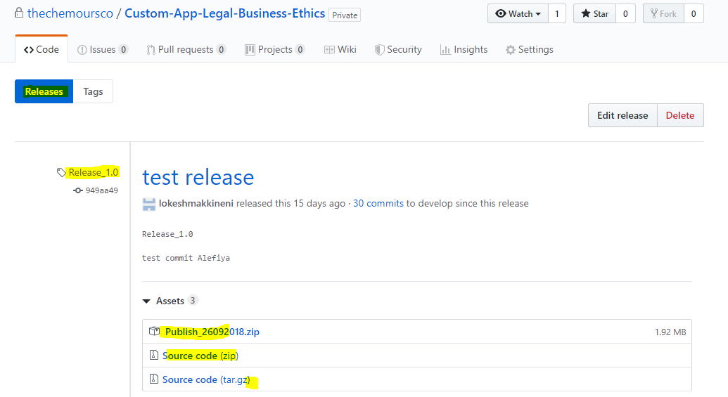

Github authentication with SAML single sign-on

Process Overview:
- To achieve the above process we need to connect the Identity provider (IDP) to the GitHub organization.
- With SAML SSO, organization administrators can invite members to connect their existing GitHub user accounts to a supported IDP.
- Below are the few available options for the Identity Providers:
  - Active Directory Federation Services (AD FS)
  - Azure Active Directory (Azure AD)
  - Okta
  - One Login
- We shall be leveraging Azure AD at Chemours
- The Identity provider (IDP) has to be integrated to the GitHub to achieve SAML single sign-on based authentication.

Integrate SAML SSO with GitHub:
- Single sign-on has been enabled from the chemours end.
- User can sign in to GitHub using below link and provide username/email id and password to login to profile.
https://github.com/
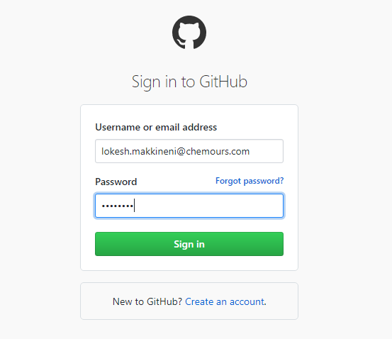
- Once sign in to user’s profile, Can access organization and will prompt for SSO login. Enter email id and password to login, it prompts for two factor authentication. Once verified allow you to access repositories inside the organization.
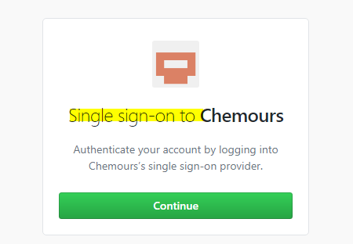

Installation of Git in the Users’ local machine and for ide integration

Process Overview:
- Git can be installed in the user machine and can be integrated with the IDE.
- User can do the day-to-day activity with the local/remote Git repositories.

Steps for Git installation

Users will have git on their local machine and they will do a few things to customize their Git environment.
Git comes with a tool called git config that lets you get and set configuration variables that control all aspects of how Git looks and operates. These variables can be stored in three different places:
- /etc/gitconfig file: Contains values applied to every user on the system and all their repositories. If users’ pass the option --system to git config, it reads and writes from this file specifically. (Because this is a system configuration file, you would need administrative or superuser privilege to make changes to it.)
- ~/.gitconfig or ~/.config/git/config file: Values specific personally to the user. Users can make Git read and write to this file specifically by passing the --global option, and this affects all of the repositories users work with on their system.
- config file in the Git directory (that is, .git/config) of whatever repository user is currently using: Specific to that single repository. User can force Git to read from and write to this file with the --local option, but that is in fact the default. (Unsurprisingly, users need to be located somewhere in a Git repository for this option to work properly.)
Each level overrides values in the previous level, so values in .git/config trump those in /etc/gitconfig.
On Windows systems, git looks for the .gitconfig file in the $HOME directory (C:\Users\$USER for most people). It also still looks for /etc/gitconfig, although it is relative to the MSys root, which is wherever you decide to install Git on your Windows system when you run the installer. If the user is using version 2.x or later of Git for Windows, there is also a system-level config file at C:\ProgramData\Git\config on Windows Vista and newer. This config file can only be changed by git config -f <file> as an admin.

User Identity Setup
The first thing user should do when they install Git is to set their user name and Chemours email address. This is important because every Git commit uses this information, and it’s immutably baked into the commits user start creating:
$ git config --global user.name "John Doe"
$ git config --global user.email johndoe@example.com
Again, user need to do this only once if they pass the --global option, because then Git will always use that information for anything they do on that system. Many of the GUI tools will help user do this when they first run them.

User’s Editor
Now that User identity is set up, they can configure the default text editor that will be used when Git needs them to type in a message. If not configured, Git uses their system’s default editor.
If they want to use a different text editor, such as Emacs, you can do the following:
$ git config --global core.editor emacs
On a Windows system, if they want to use a different text editor, they must specify the full path to its executable file. This can be different depending on how the editor is packaged.
In the case of Notepad++, a popular programming editor, they are likely to want to use the 32-bit version, since at the time of writing the 64-bit version doesn’t support all plug-ins. If the users are on a 32-bit Windows system, or they have a 64-bit editor on a 64-bit system, then type something like this:
$ git config --global core.editor "'C:/Program Files/Notepad++/notepad++.exe' -multiInst -nosession"
If they have a 32-bit editor on a 64-bit system, the program will be installed in C:\Program Files (x86):
$ git config --global core.editor "'C:/Program Files (x86)/Notepad++/notepad++.exe' -multiInst -nosession"

Checking User Settings
If you want to check your configuration settings, you can use the git config --list command to list all the settings Git can find at that point:
$ git config --list
user.name=John Doe
user.email=johndoe@example.com
color.status=auto
color.branch=auto
color.interactive=auto
color.diff=auto
...
The user may see keys more than once, because Git reads the same key from different files (/etc/gitconfig and ~/.gitconfig, for example). In this case, Git uses the last value for each unique key it sees.
The user can also check what Git thinks a specific key’s value is by typing git config <key>:
$ git config user.name
John Doe

Getting Help
If user ever need help while using Git, there are two equivalent ways to get the comprehensive manual page (manpage) help for any of the Git commands:
$ git help <verb>
$ man git-<verb>
For example, they can get the manpage help for the git config command by running
$ git help config

IDE Integration
- All Git Operations can be performed directly from the IDE (visual studio, Android studio, Xcode, Eclipse etc.)
- IDE should be integrated in developer’s machine and

